**LocationMap Page Design**

**Elements:**

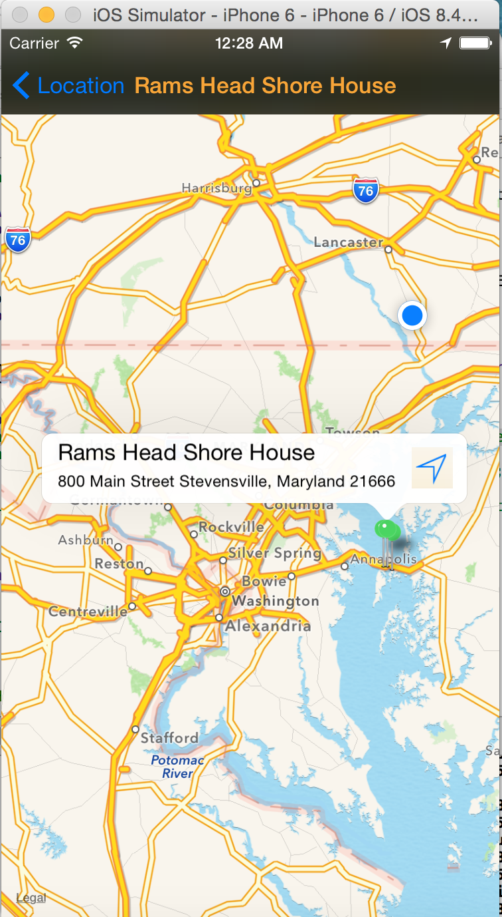Title: Restaurant name, orange

Navigation Button: “Location”, blue; back to last page(Location List)

MapView:

1. showing the name and location of the restaurant(center as the selected restaurant) with pins

2. showing current location with blue point

Green pin:

1. showing the name and detail address of the pin

2. click the right button on the pin view could open a navigation app(from current location to selected pin)—see image of next page

